Create login page, the user can access page via **/login** as following

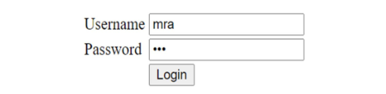

When user click login button, if username password is wrong, the system displays “**Login failed**”.

Otherwise the system displays “**Login successful**”.

Create list of employee, the user can access page via **/list**

* If user does not login to the system, the system displays “Access denied!”
* Otherwise load all employees who created by the logged user as following

